Welcome to South Wilts Grammar School from Friends of SWGS
As a Parent's Association we rely 100% on volunteers.

YOU ARE A MEMBER: As a parent or carer you are automatically a member of the Friends of SWGS, otherwise known as the Parent's Association. We are a registered charity (No 1004467) with the aim of providing a community that supports SWGS in its aims and ideals.

WHAT WE DO & HOW YOU CAN GET INVOLVED: Our organising committee meets several times a year (mostly online) and anyone is welcome to attend as and when you can. We are always looking for help to support school events such as concerts or parents’ evenings and if you would like to get further involved in helping to run our various events and fundraising activities, we would be delighted to accept your support.

1000 CLUB: The 1000 Club is an ongoing fundraising activity which raises money for our childrens’ enrichment at school. Add a bit of excitement to your life for only £1 a month! Each number only costs £12 for entry into 12 consecutive monthly lottery draws! The more numbers you buy the GREATER YOUR CHANCE OF A GREAT CASH PRIZE!
​The usual monthly first prize is £100, second prize will give you £50 and third prize is £25.
How to join: Very simple! Simply fill in the form online www.friendsofswgs.org.uk/1000-club
and sort preferred payment. It would be wonderful if you set up a Standing Order with your bank as this means we avoid high bank charges and renewal each year is automatic, meaning you never miss a draw. Anyone associated with the school can join: don’t have to be Mum or Dad, although you do have to be over 18. You can also pay by BACS: please ensure that you use your daughter/son’s full name & form group as your reference. Cheques are also welcome: payable to FoSWGS.

HOW DO WE HELP: Our fundraising activity is becoming increasingly important as school budgets come under ever increasing pressure. All the money raised goes back to the school to pay for items not otherwise affordable. Over the years we have helped to fund the new music department refit, new food tech rooms to providing team sports kit & Mini buses, every penny helps. Recently we have had more of a ‘Wellbeing’ focus for our committee as we feel we need to support our children face the increasing stress life has presented them – so have helped departments purchase birdboxes with webcam, a weather station, new literacy/EDI murals, sports kit, transportable keyboard for community performances and various items for Pastoral wellbeing – a Japanese Zen Garden, wireless headphones and breathing board.

HOW WE COMMUNICATE: We have a Website - www.friendsofswgs.org.uk – and we feature on Facebook, Instagram and, of course, Classlist.
CLASSLIST: We put all or our news and events up on Classlist. Itʼs a free, safe, secure online community for the school where you can post questions and message other parents in your childʼs class or year group. It is really useful for tracking down lost jumpers, organising play dates and checking the homework. WE HAVE 1300 MEMBERS.
Classlist also enables you to share your contact details with other parents in the same year group. You have full control over your privacy settings and can also join and use Classlist without sharing your contact details.
When your child receives a Welcome Pack in June you will need to SIGN UP/ DOWNLOAD the Classlist App with your child’s NEW FORM CLASS details. Or visit www.classlist.com and then search for our school name.

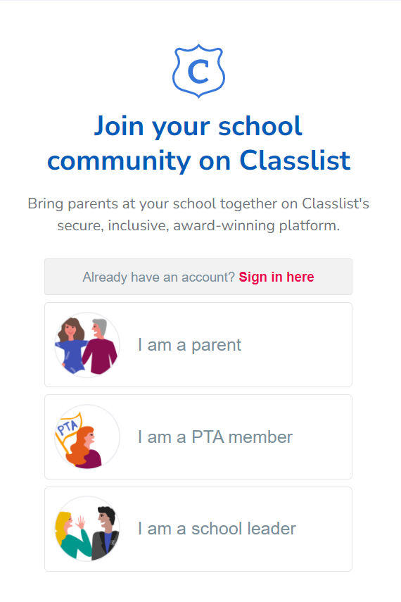
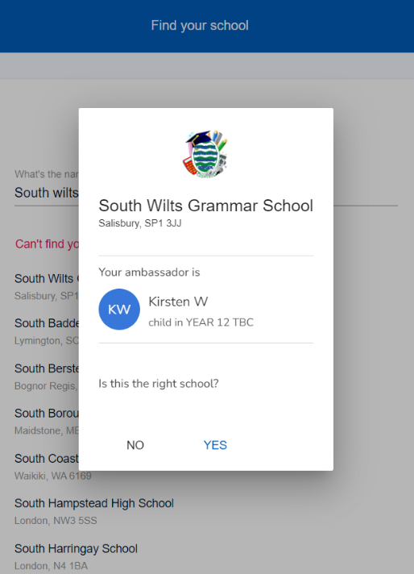
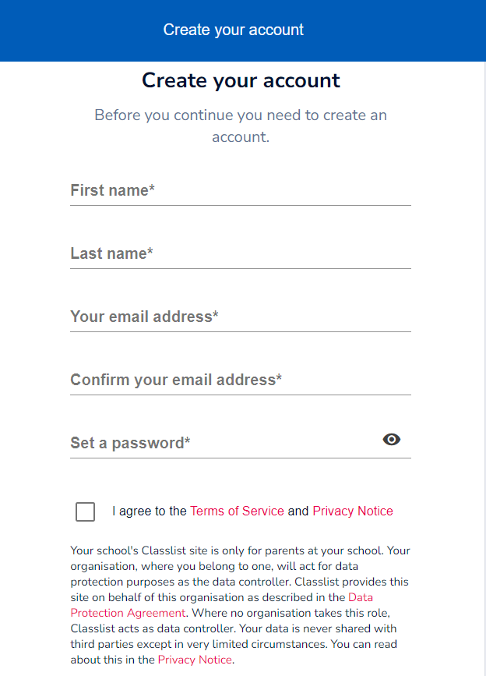

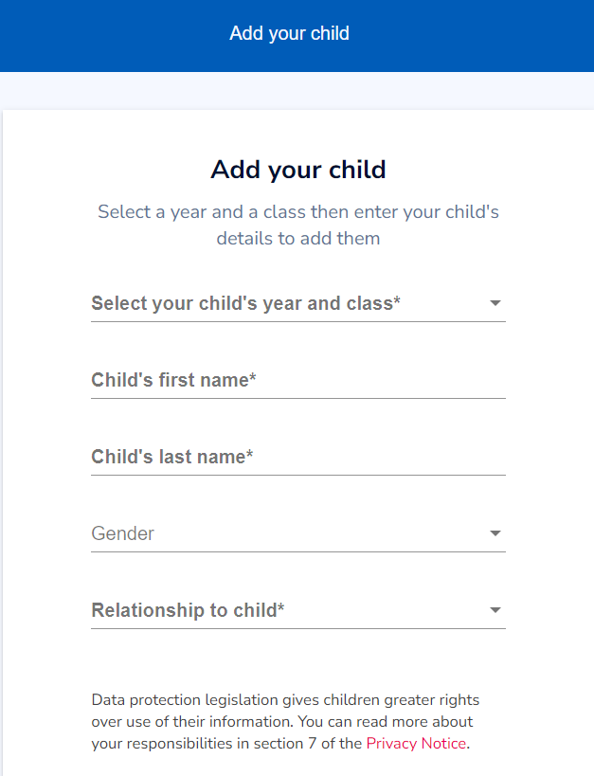
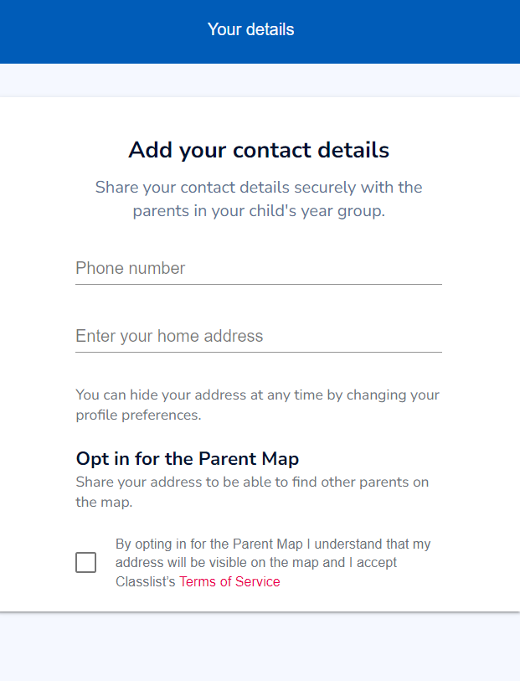
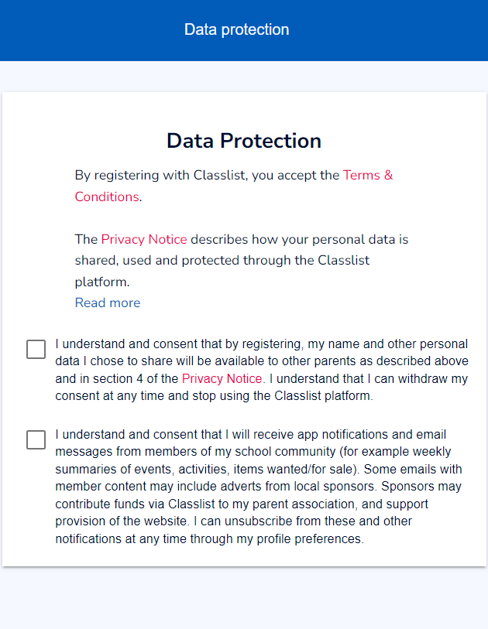
Then you can get chatting with the other parents and weʼll be able to invite you to our upcoming events.
If you have any questions about Classlist please email us on FriendsofSWGS@gmail.com and we will endeavour to get back to you as quickly as possible.

We are also here to support the students and families and enjoy facilitating and supporting social & extra-curricular events.
We would love you to share your ideas and thank you for your support. ​

Kirsten Webster
Chair.

